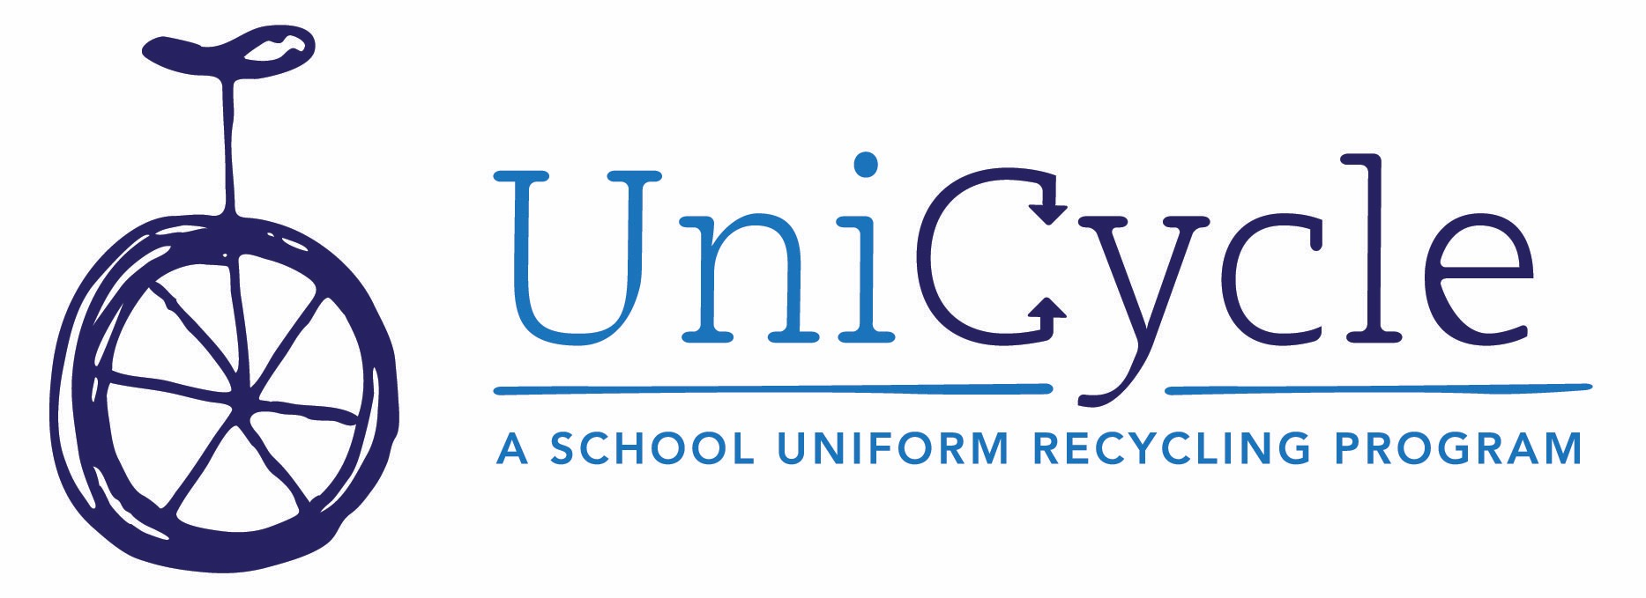
WHAT IS UniCycle?
UniCycle is a school uniform recycling program that orchestrates the collection and redistribution of outgrown, gently-used clothing to provide Standard School Attire (SSA) to Metro Nashville Public School students who need it. Volunteers collect clothing in participating schools, then redistribute it through a partnership with the Homeless Education Resource Office for Families in Transition (HERO), and by implementing in-school UniCycle Exchange closets. These closets are maintained by a volunteer UniCycle Coordinator at each school, and teachers and counselors can give clothes on an as-needed basis with no red tape.
UniCycle brings the practice of sharing “outgrown, not worn out” clothing from a family or neighborhood model to a citywide model. UniCycle is a way to take care of our most vulnerable kids, leaving school personnel and HERO more time and money to tackle the bigger issues surrounding homelessness and poverty among students and how those challenges affect their school day.
Most schools in the Metro Nashville Public School system require Standard School Attire in the form of collared, solid-color shirts and khaki, navy blue or black pants, shorts, skirts or dresses.
HOW DOES IT WORK?
Students bring their outgrown SSA items to school and the clothing is corralled in a designated UniCycle laundry basket. Volunteers collect the baskets when full and clothes are carefully screened, cleaned, organized and then sent home to students via the Homeless Education Resource Office or directly back to school closets to be given out freely. Efficient collection and redistribution at the school level makes things quicker and easier for parents and students on both ends of the recycle stream.
HOW DOES IT HELP?
By serving as both collection and redistribution agency with drop off and pick up points primarily in schools, UniCycle condenses the to-do list on either side of the recycle model. We serve as the one-stop destination for parents seeking a charitable option for out-grown uniforms and the same endpoint for other families searching for gently used SSA for their school-aged children.
The entire UniCycle program works diligently to support the efforts and mission statement of HERO, which operates within the public school system and oversees school enrollment, transportation, school clothing, supplies and other education issues for students who are experiencing homelessness. Recycling SSA for some of these students keeps more money and time in the HERO budget to fulfill the program’s critical mission.
FOR MORE INFORMATION:
Jami Oakley: 713.301.7815 and Unicycle.nashville@gmail.com

