UniCycle Exchange Coordinator Checklist

Responsibilities

- Secure appropriate school approvals to implement program

- Manage relationship with school administration/counseling team and serve as liaison between school and UniCycle

- Monitor and empty UniCycle laundry basket

- Get the word out to parents and students to make program successful

- With clothing:
- Sort - check out each item and make sure it is in condition such that you would still be happy to send your child to school in it
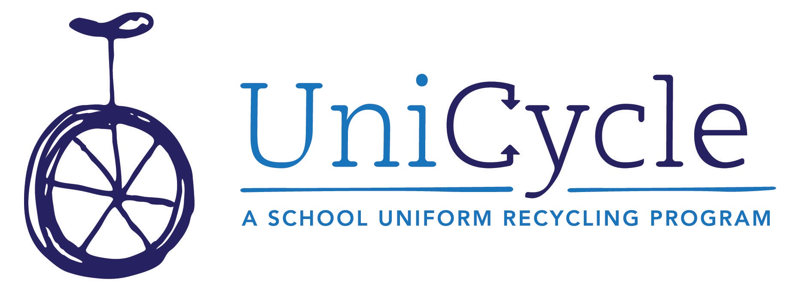
- Wash - If something needs a run through the wash, please wash it, or put in a separate “to be washed” bag before delivery to appropriate UniCycle leader. An item could need to be washed because it is not fresh, or because you see a stain that you think could come out with a good stain remover and run through the wash. Give it a try if you can.
- Fold and Fill school’s clothing closet and/or deliver to staff person at school who manages the closet
- Notes: If a perfect pair of boys’ shorts has an ink stain on the pocket - they are still wearable! We may just give that student three pair instead of two. If an item is stained, worn or torn beyond repair, please donate to Goodwill or toss it as appropriate. Use your judgement - don’t let the “to keep or not to keep” step hang you up!

Start-Up Checklist

School Administration Approvals

- To launch program
- To advertise to parents and students via available media (fliers, emails, newsletters, etc.)
- To align with PTO (the PTO’s support is valuable, and to be sure there are no competing efforts being made and that any and all cross-promotions are taken advantage of)
- To setup the UniCycle basket and signage at a mutually agreed-upon location - preferably somewhere highly visible to parents, such as the main office or entrance to the school
- To have access to school’s current emergency clothing closet. In general, it makes sense for the UniCycle Coordinator to do an initial inventory of the school’s existing closet, send extras to UniCycle hub, fill in holes where needed, and to continue to do this a few times a semester or as needed. Your school may also offer to donate the contents of the “Lost and Found” closet at the end of each year.

Get the Word Out - Perhaps the most important part!

- All-School emails
- School Facebook Page
- UniCycle Facebook Page
- Your own person social network outlets and friends/other parents who you feel comfortable emailing
- Fliers - in Friday folders, on bulletin boards, etc.
- Visible collection basket and signage in school
- Attend and speak at PTO and Teacher/Admin meetings
- Engage service groups and clubs within the school - Girl or Boy Scout troops, student council, Honor Society, etc. This works especially well at the Middle School level and beyond.

Show Progress and Appreciation

- Thank you notices - maybe something posted above the basket or on the school’s Facebook page or school newsletter after a particularly fruitful collection period
- News with milestones reached (i.e. 100th item of clothing collected today from our UniCycle basket!; 300 students served by UniCycle this semester, etc.)
- Take photos, provide numbers or stories to be used to add interest to the UniCycle Facebook/Twitter page
- Keep in contact with school principal/admin/counseling team about the progress of the program and ensure that they know the door is open should the school have more needs than anticipated. We do not want schools to feel like we are taking clothing that could be used by their own students and instead offering them to other students. Transparency is key.

Special Events

- Drive-by Donation Day - Host a day when UniCycle volunteers pick up donations from car windows during drop-off and pick-up time in the hook-up line. Easier than ever for parents and also builds awareness of the program

- Specific Item Drive (new socks, underwear, etc.) - could be a contest of sorts per grade or class. Could be hosted, with school support, when a school or the HERO office has a specific need

- See additional ideas on the “How to Help UniCycle” document on the Google Drive or request a copy from Jami

Each UniCycle Coordinator has autonomy to run his or her school as is fitting, but also, don’t reinvent the wheel and don’t make yourself crazy! There are signs and fliers drafted, newsletter copy written, and always someone to bounce ideas off of. There is a Google Drive account with a library of documents for you to use as-is, peruse for ideas, or copy and paste verbiage to create the particular document that you need. Please keep in touch and ask for help - this does not have to be overly time-consuming, but most certainly will be exponentially rewarding for all involved, from the UniCycle volunteers to the parents and kids who donate, to the students who receive awesome ‘almost new’ clothing to make them feel great as they start each school day! Thank you for being a part of this fantastic effort!

Jami Oakley, 713.301.7815, jami.m.oakley@gmail.com

