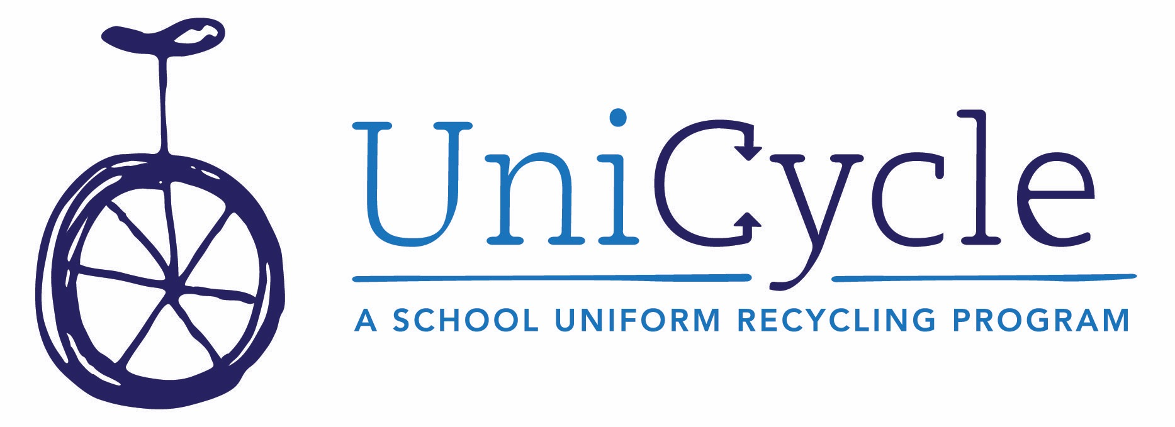
WHAT IS UniCycle?
UniCycle is a school uniform recycling program that orchestrates the collection and redistribution of “outgrown, not worn out” clothing to provide Standard School Attire (SSA) to Metro Nashville Public School students who need it. SSA is collected in participating locations, then quickly redistributed to students through a partnership with the Homeless Education Resource Office for Families in Transition (HERO Program) or within schools by stocking their individual clothing closets with quality SSA ready to be given away as needed by teachers, counselors and other school personnel.
When UniCycle partners with schools, the first item on the agenda is to set up that school with its own robust internal clothing closet, drawing from clothing collected in all participating UniCycle schools and relying on a network of volunteers and school staff to ensure that each closet has what it needs and that excess is efficiently used by other schools and HERO.
WHAT WE COLLECT
Gently-used (or new!) clothing that meets the requirements of Standard School Attire in the Metro Nashville Public School district. Clean out your kids’ closets, or buy an extra if you spot a fantastic sale – it will be put to effective use by MNPS students who will start their day feeling great.
This includes:
- Collared shirts in solid colors, all sizes, long and short-sleeved (i.e. polo-style shirts)
- Shorts, Pants and Skirts in Khaki, Navy Blue and Black
- Girls’ Uniform Dresses in Khaki, Navy Blue and Black
- Belts
- Leggings – all colors and patterns (to wear under skirts and dresses)

